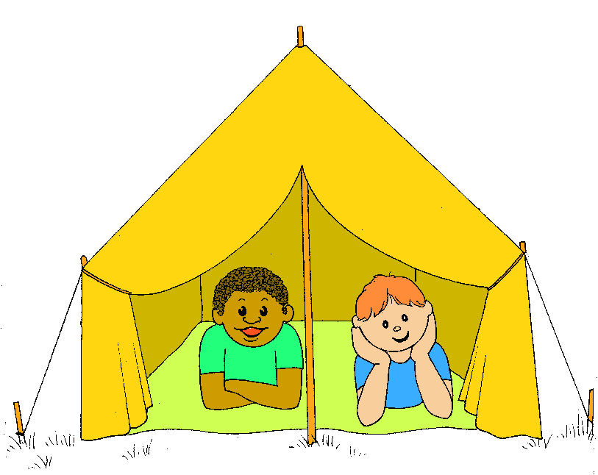
Summer Camp
Summer campin’ going to summer camp.
Summer campin’ going to summer camp.
Summer campin’ going to summer camp.

All my friends from far and near are packing up a ton of gear.
Now’s the day we leave for summer camp.
Filling up our sleeping sacks with candy bars and extra snacks.
We can’t wait to get to summer camp.

Suntan lotion, safety kit, hiking boots and baseball mitt:
Maybe we could do a skit at my summer camp.
Bug repellent, Tylenol, batteries and bocce ball;
Mom made sure we got it all going to summer camp.

Summer campin’; we can’t wait to get to summer camp.
Summer campin’; going to summer camp.

Who knows what it’s really like? I heard they make you swim and hike.
Now’s the day we leave for summer camp.
Solo: They say camp is really cool. I’d rather go to summer school (EW!)
We can’t wait to get to summer camp.

Fishing pole, mosquito net, meeting kids we never met.
(mother solo) Don’t forget a moist towlette. MOM!
At my summer camp.

Everybody come along, here at camp we all belong.
We might sing a camping song.
Part1: Kum ba yah.
Part 2: Kum ba yah.
Part 1: Kum ba yah.
Part 2: Kum ba yah.

Summer campin’; we can’t wait to get to summer camp.
Summer campin’; going to summer camp.
Summer campin’; we can’t wait to get to summer camp.
Summer campin’; going to summer camp.
Goin’ to summer camp,
Goin’ to summer camp.
Going to summer camp.

